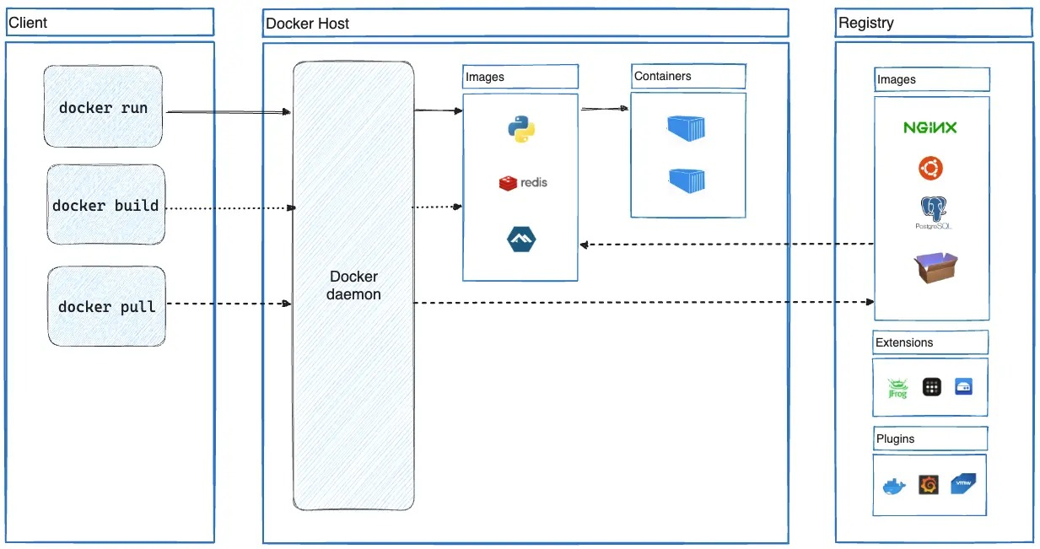

Docker Architecture – Quick Notes
1. Docker Daemon (dockerd)
The background service that manages Docker. Listens for Docker API requests. Handles images, containers, networks, volumes, etc. Can communicate with other daemons.
2. Docker Client (docker)
Command-line tool users interact with. Commands like docker run, docker pull, docker push. Sends requests to the Docker daemon via Docker API. Can connect to multiple daemons.
3. Docker Desktop
Easy setup application for Mac, Windows, and Linux. Includes: Docker daemon Docker client Docker Compose Kubernetes Credential Helper Used mainly for local development.
4. Docker Registry
Stores Docker images. Default public registry: Docker Hub Supports private registries. Commands: docker pull → download image docker push → upload image Docker Objects
5. Images
Read-only template used to create containers. Built using a Dockerfile. Each instruction creates a layer. Lightweight and reusable.
6. Containers
Running instance of an image. Can be started, stopped, removed.
Isolated from host and other containers. Ephemeral by default (data lost unless stored in volumes).
Example Command docker run -it ubuntu /bin/bash
What happens: Pulls Ubuntu image (if not present locally). Creates a container. Adds a writable layer. Assigns network & IP. Starts /bin/bash interactively. On exit, container stops (not deleted).
One-Line Summary
Docker = Client → talks to → Daemon → manages → Images & Containers → stored in → Registry.

